Data science for business (DS4B) course final report

HER

ACHIR Charafeddine & QI Jiayi

[charafeddine.achir1@gmail.com](mailto:charafeddine.achir1@gmail.com)

jiayi.qi@etu.univ-cotedazur.fr

1. Introduction

HER is a company poised to help improve women's health care from the ground up. HER's philosophy is to meet women's health needs through technology. Use wearable devices such as smart watches and IoT devices ie. weight scales to record womens health data. Predict and monitor some potential diseases or gynecological diseases through questionnaires, heart rate monitoring, weight status and other data.

In addition, we will work with women's health organizations and research institutions and hospitals dedicated to women's health to promote the program to increase the popularity and credibility of the program, so as to continuously improve women's understanding of their own health in underdeveloped areas.

1. Problem identification

In contexts where women's health is undervalued, the technology fits into the broader innovation of FemTech. Key participants include global health advocates and tech innovators, with factors such as cultural differences, scarcity of medical resources, and lack of awareness about women-specific health issues. This technology addresses women's health issues prevalent in underdeveloped areas, like the diversity of gynecological diseases and inadequate diagnosis. It aims to solve the problem of misdiagnosis and missed treatment opportunities due to insufficient medical resources and inexperienced hospitals. The goal is to improve women's health in underdeveloped areas through better disease identification and health management. Expected impacts include reducing misdiagnosis, improving treatment effectiveness, and enhancing women's awareness and control over their health.

1. Business Research

The solution could rely on both supervised and unsupervised data science methods.

3.1.1 Supervised Learning

We use surveys and data monitoring to classify described clinical symptoms, aiding women in better understanding their health conditions. For instance, machine learning models can be trained using specific symptoms and physiological data to predict and identify any particular health issues.

3.1.2 Unsupervised Learning

By tracking and analyzing data, we aim for more general disease diagnoses. For example, analyzing anomalies in heart rate to assess the risk of heart diseases. Unsupervised learning helps in discovering potential health risk patterns in unlabeled data.

Evidence supporting the effectiveness of these methods comes from research in predictive health analytics and pattern recognition in medical data.

3.2 Data collection

We plan to use periodic questionnaires and tracking via smart devices to gather data, which will then be uploaded to servers. Our algorithms will assess users' physical health conditions based on this data and provide feedback accordingly. This approach combines active user input (through questionnaires) and passive data collection (via smart device tracking), ensuring comprehensive and accurate data gathering. By analyzing the data with our algorithms on the server, we can provide valuable health insights and advice, helping users better understand and manage their health conditions.

3.3 Marketing

The global women's digital health market was valued at USD 1.8 billion in 2021 and is expected to reach USD 6.5 billion by 2028, growing at a CAGR of 19.9% from 2021 to 2028. This market includes mobile apps, wearable devices, diagnostic tools, and other technologies focused on women's health. The reproductive health segment has been particularly dominant, accounting for a large revenue share due to high adoption rates of mobile applications for female healthcare management

FemTech companies are increasingly gaining traction with significant investments. For instance, Progyny, which manages fertility benefits, and Maven Clinic, a virtual clinic for women's and family health, both have valuations over $1 billion. The FemTech market size ranges from $500 million to $1 billion, with potential for double-digit revenue growth. These companies cover various aspects, including maternal health, menstrual products, gynecological devices, and fertility solutions

North America has been a dominant player in the women’s health technology market due to advanced technological infrastructure and higher disposable incomes. However, the Asia Pacific region is expected to witness the fastest growth, with emerging economies like China, India, and Singapore showing strong economic growth and increasing awareness about women's health technologies

The market is served by companies like HeraMED, iSono Health, Clue by Biowink, and others. These companies are exploring artificial intelligence, machine learning, and the internet of things to develop applications and devices addressing women's healthcare concerns​

This data indicates a rapidly growing market with significant opportunities for innovation and development in women's health technology.

1. Business proposal

4.1 Service

The proposed solution is a women's health monitoring service using wearable devices and a mobile app. The added value comes from offering personalized health insights using machine learning algorithms. These insights can include early detection of potential health issues, tailored health advice, and tracking of key health metrics.

4.2 Customers and Market

The primary customers would be women seeking proactive health management, particularly in regions where healthcare resources are limited. The market also includes healthcare providers who could use the data for better patient care.

4.3 Potential Business Model

A subscription-based model would be suitable, providing basic monitoring services for free while offering advanced insights, personalized health plans, and additional features for a monthly fee. Partnering with healthcare providers and insurance companies could provide an additional revenue stream.

4.4 Go-To Market Strategy

Partnerships with Hospitals and Health Organizations: Establish collaborations with local hospitals and health organizations to promote your product. This can enhance the credibility and visibility of your product.

4.5 Community Pilot Programs

Implement pilot projects in selected communities and gradually expand the scope. This helps in gathering initial user feedback and testing the product in real-world settings.

4.5.1 Social Media Advertising: Utilize social media platforms for advertising campaigns, which can quickly reach your target audience and increase product awareness.

4.5.2 Free Monitoring and Tracking: Offer free monitoring and tracking services in the initial phase to attract users to try the product. This strategy can help rapidly build a user base.

4.5.3 Lifetime Free Subscription Offers: Provide lifetime free subscription slots to early registrants as a reward for their early support and as a strategy to attract new users.

4.6 Value Chain

The value chain involves hardware manufacturers for wearable devices, software development teams for app development, data scientists for algorithm development, and healthcare professionals for insights and validations.

4.7 Regulation and Environmental Impact

Compliance with health data regulations like HIPAA in the U.S., GDPR in Europe, and local healthcare regulations is essential. The environmental impact should be minimized by using sustainable materials in wearable devices and ensuring responsible data center practices.

1. Conclusions and recommendations for next steps

5.1 Further Research

5.1.1 Data Security and Privacy: Research how to protect user data security and privacy under different legal frameworks, employing advanced encryption and data handling technologies.

5.1.2 Continuous Algorithm Optimization and Accuracy Improvement: Continuously optimize the algorithm based on user feedback to improve the precision of predictions and monitoring, expanding the user base for more accurate model training.

5.1.3 User Experience and Interface Optimization: Adjust the interface and program based on user feedback to enhance the user experience and the application's usability.

5.2 Product Development Roadmap

5.2.1 First Version: Our inaugural prototype is now available and fully operational. It specializes in predicting heart diseases for women using easily collectible basic health data. It has demonstrated an exceptional level of accuracy during testing, showcasing significant promise for future applications. At the time of launch, the application will be able of monitoring basic health data (like heart rate and menstrual cycles) and providing fundamental health insights.

5.2.2 Within One Year: Add advanced features such as personalized health recommendations, disease warning services, and integration with smart devices.

5.2.3 Future Development: Develop more advanced AI health guidance, build a community interaction platform, include remote medical consulting services, and continue exploring new health monitoring technologies and services.

5.3 Implications for the future development of the technology

The project "HER" utilizing machine learning for women's health monitoring is set to make a significant impact on the landscape of healthcare technology. This project embodies a holistic approach to women's health, harnessing the power of advanced data analytics to provide personalized and predictive healthcare solutions. By integrating emerging technologies and focusing on user-centric design, "HER" aims to address a wide range of women-specific health issues, thereby enhancing healthcare accessibility, personalization, and preventive care. The project's commitment to data privacy and security, along with its potential to spur further research and development in women's health, positions it as a pioneering initiative in the field of FemTech. "HER" stands as a testament to the transformative potential of technology in revolutionizing women's healthcare.

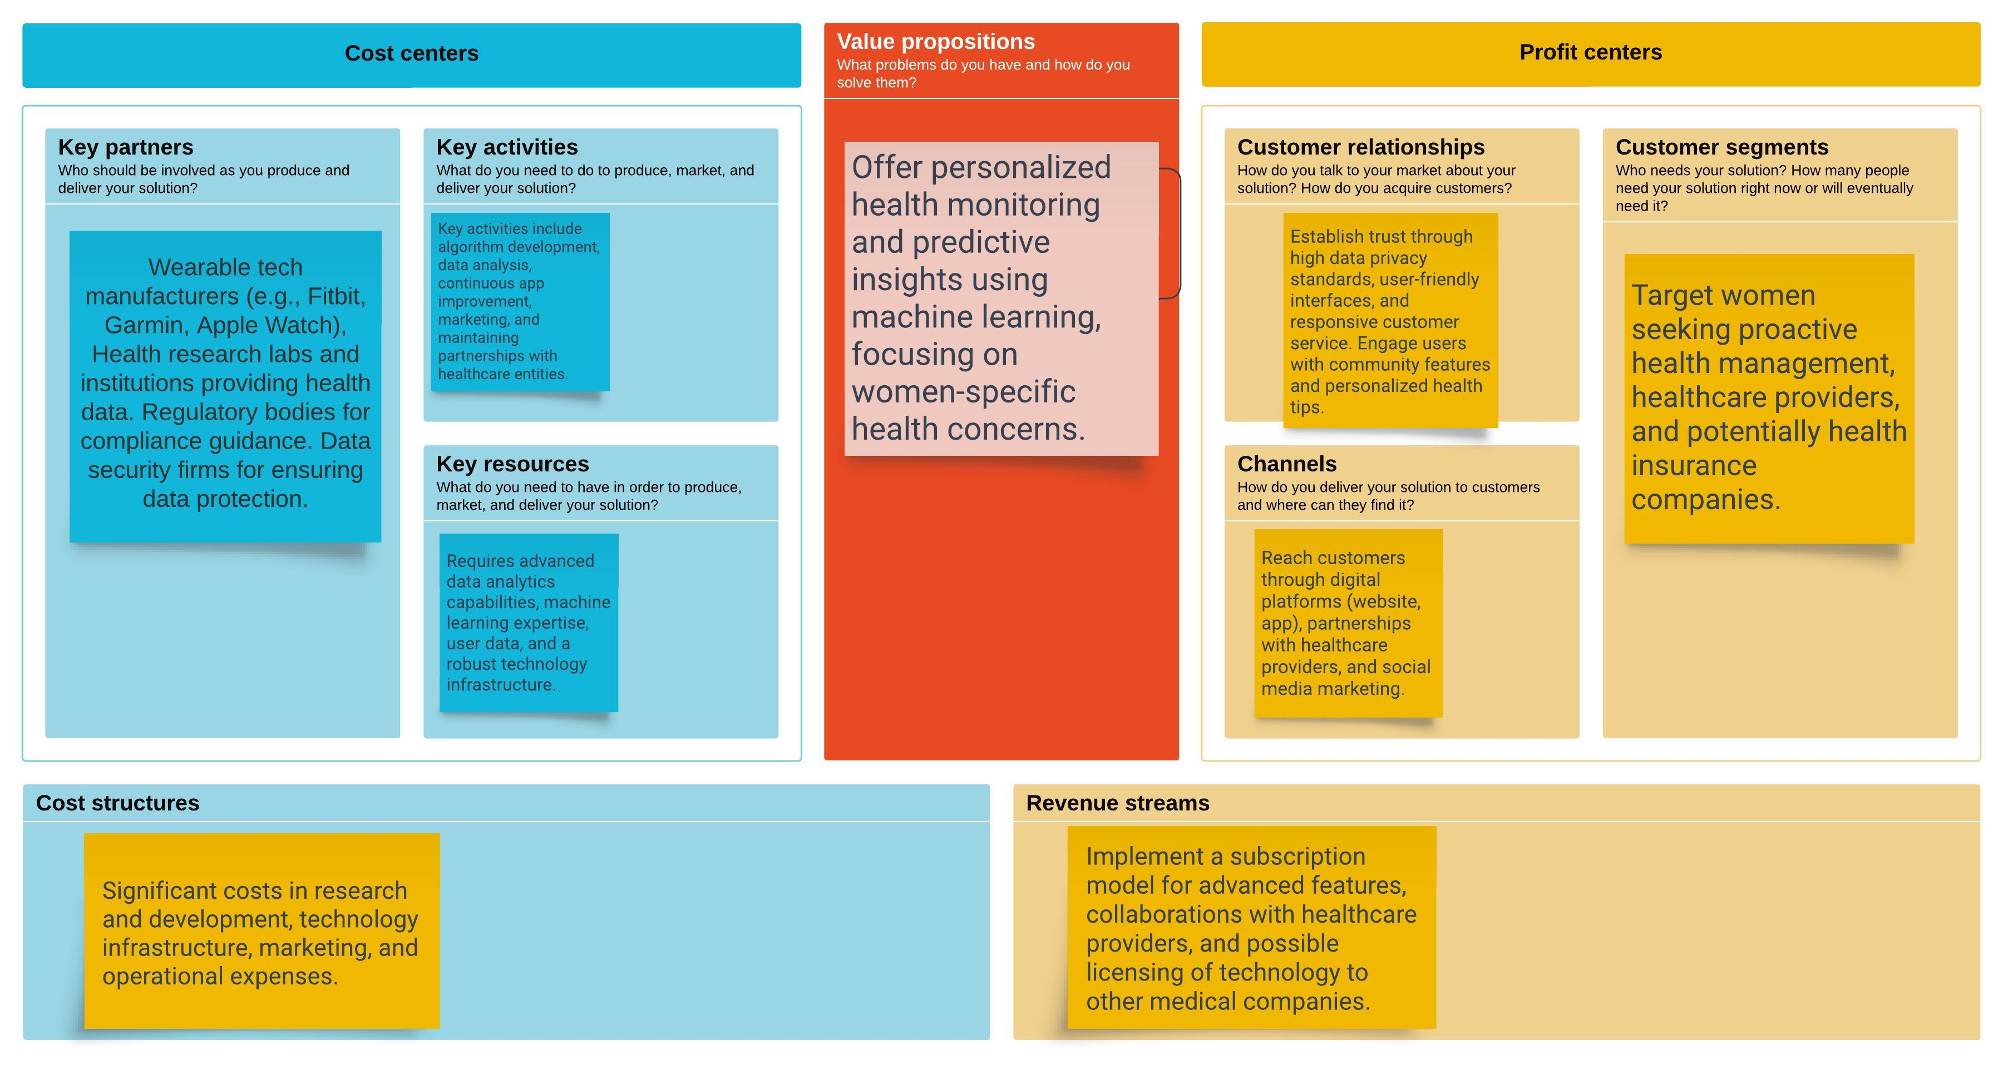

1. References, web links

<https://www.grandviewresearch.com/industry-analysis/women-digital-health-market>

<https://www.mckinsey.com/industries/healthcare/our-insights/the-dawn-of-the-femtech-revolution>

<https://www.fortunebusinessinsights.com/industry-reports/women-s-health-technology-market-100365>

<https://www.vantagemarketresearch.com/industry-report/womens-digital-health-market-2228>